BIRLA INSTITUTE OF TECHNOLOGY & SCIENCE, PILANI
Work Integrated Learning Programmes Division
Second Semester 2024-2025
Comprehensive examination
(EC-3 Regular)
Course No. : AIMLCZC418
Course Title : Introduction to Statistical Methods
Nature of Exam : Open Book
No. of Pages = 8
No. of Questions = 8
Weightage : 40%
Duration : 2 Hours
Date of Exam : 28-02-2026_FN
Note to Students:
- Please follow all the Instructions to Candidates given on the cover page of the answer book.
- All parts of a question should be answered consecutively. Each answer should start from a fresh page.
- Assumptions made if any, should be stated clearly at the beginning of your answer.

Q1. The Delhi Government's Department of Environment and Climate Change is investigating the relationship between rising summer temperatures and household electricity consumption, primarily driven by air conditioner usage. Understanding this link is crucial for load forecasting and preventing power grid failures during heatwaves.
A junior analyst at the department has compiled average monthly data for the last season (May to September) from a representative sample of households in South Delhi: [5 marks]

Month | Average Temperature (°C) (X) | Average Electricity Usage (kWh) (Y)
May | 38 | 320
June | 41 | 380
July | 35 | 290
August | 33 | 270
September | 31 | 240

As a new intern in the Urban Sustainability Unit, you have been asked to support this analysis.
- Calculate Karl Pearson’s coefficient of correlation (r) between the average monthly temperature and average electricity usage.
- Interpret your result in the context of urban energy planning in Delhi. What does this correlation suggest about the city's energy demand during extreme heat events?
2. A logistics company uses Simple Exponential Smoothing to forecast monthly demand for a machine-learning inference service deployed on cloud servers. The demand (in thousands of requests) for the past six months is shown below: [5 marks]
Month | Jan | Feb | March | April | May | June
Demand | 82 | 88 | 91 | 97 | 95 | 102

The initial forecast for January is assumed to be equal to the actual demand in January.
Answer the following:
- Forecast the demand for July using a smoothing constant α=0.4.
- Forecast the demand for July using a smoothing constant α=0.7.
- Briefly comment on, which α value is more suitable if sudden spikes in demand are expected in real-time AI applications.
(All calculations must be shown clearly. Use Simple Exponential Smoothing only.)

Q3.a) Scores of 6 postgraduate students before and after a revision strategy are given below:
[3 marks]
Before | 32 | 35 | 30 | 33 | 31 | 34
After | 36 | 38 | 34 | 37 | 35 | 39
At the 5% level of significance, test whether the strategy improves performance. 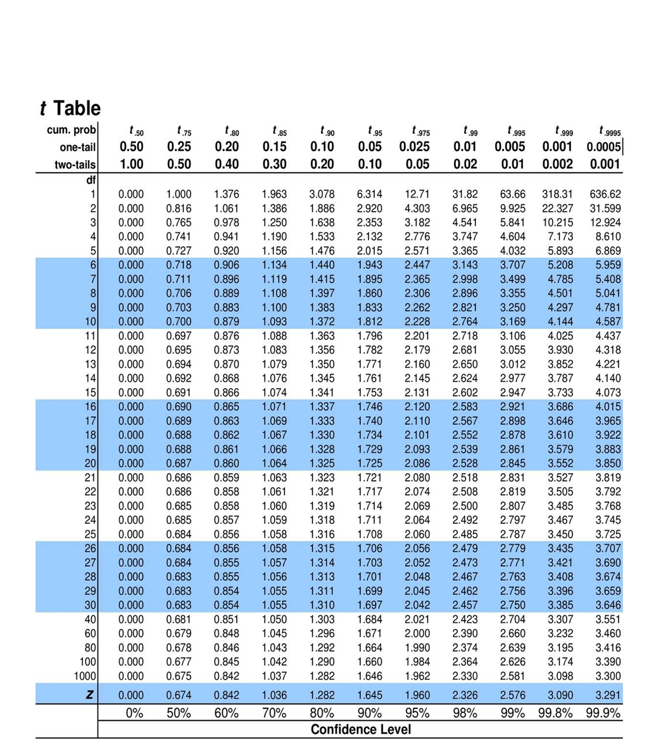
b) Medi Scan AI claims its tool Derm Assist reduces average diagnosis time for high-risk skin lesions by 20 minutes compared to standard care. A hospital tests it on 36 patients and finds a mean time reduction of 18.2 minutes, with a known population standard deviation of 7.5 minutes.
As a data scientist, evaluate this claim at the 5% significance level. Formulate appropriate hypotheses, perform the test, and interpret your conclusion in the context of clinical deployment—considering both statistical evidence and the risk of decision errors. [2 marks]
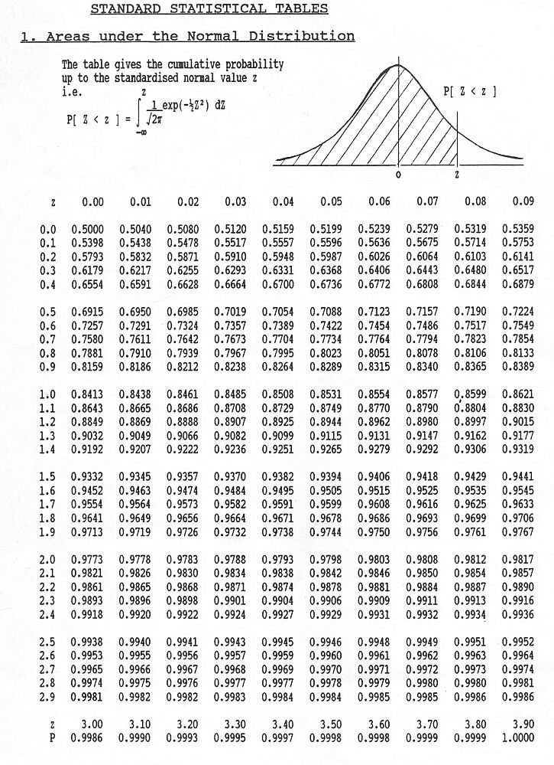
- A horticulturist in Kolkata conducted an experiment to study the effect of three irrigation methods - Drip, Sprinkler and Flood on mango yield (kg per tree). The experiment was carried out across four orchard blocks (Block 1 to Block 4) to account for natural variability among orchards. Each irrigation method was applied once in each orchard block and the average yield per tree after one growing season was recorded as shown below. [5 marks]
Orchards →  Irrigation ↓ | Block 1 | Block 2 | Block 3 | Block 4
Drip | 22 | 20 | 24 | 22
Sprinkler | 21 | 19 | 23 | 21
Flood | 18 | 16 | 20 | 18

Assume that there is no interaction between irrigation methods and orchard blocks.

At the 5% level of significance, test the following hypotheses:

H₀: Orchards do not differ in yield and Irrigation methods do not differ in yield
H₁: Orchards differ in yield and Irrigation methods differ in yield
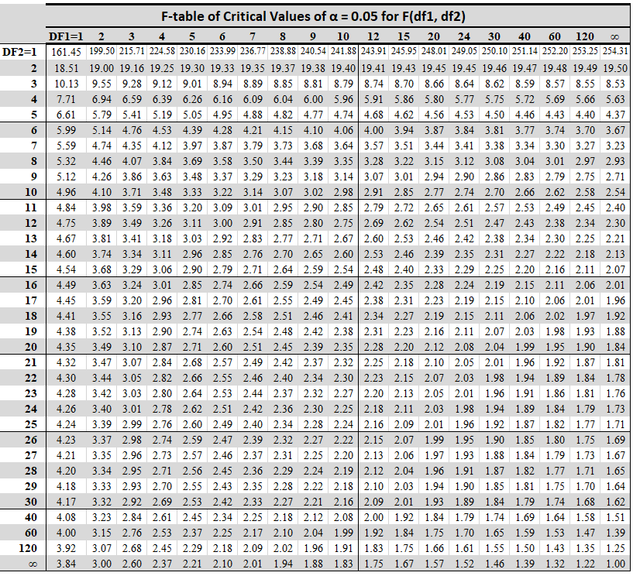
- The Mumbai Urban Farming Initiative (MUFI) is piloting IoT-enabled smart irrigation systems in rooftop vegetable gardens across Mumbai. Each garden is equipped with soil moisture sensors and automated drip emitters. As part of a pilot study, MUFI collected data from 10 representative gardens over one growing season (June–August 2025). For each garden, they recorded: [2+1+2 marks]
X: Average daily water input (liters per square meter, L/m²/day) controlled by the system
Y: Crop yield (kg/m²) measured at harvest for leafy greens (e.g., spinach, lettuce)
The goal is to model the relationship between water input and yield to optimize resource use and avoid over-irrigation (which causes nutrient leaching and higher energy costs).
Garden ID | X (L/m²/day) | Y (kg/m²)
G1 | 3.0 | 1.8
G2 | 4.2 | 2.5
G3 | 2.5 | 1.6
G4 | 5.1 | 2.9
G5 | 3.8 | 2.3
G6 | 6.0 | 2.7
G7 | 2.0 | 1.2
G8 | 4.5 | 2.6
G9 | 5.5 | 2.8
G10 | 3.3 | 2.0
- Fit a simple linear regression model: Y= β₀ + β₁X
- Discuss whether the linear model is appropriate. What does the pattern suggest?
- Based on your analysis, what is the optimal water input range (in L/m²/day) for maximizing yield per unit water (i.e., water-use efficiency)? Justify using your model and real-world constraints (e.g., water scarcity in Mumbai).

- A university cafeteria collects lunch duration (in minutes) of 10 students: {18, 20, 22, 25, 27, 35, 38, 40, 42, 45}. The data appears bimodal and is modeled using a two-component Gaussian Mixture Model (GMM). [5 marks]
Assume:
Component 1: First 5 values (quick eaters)
Component 2: Last 5 values (leisurely eaters)

(a) Write the probability density function of a two-component GMM.
(b) Estimate the mean and variance for each component.
(c) Compute the mixing coefficients.
(d) Briefly explain how GMM helps identify different student lunch behaviors.

- a) A study of the ability of individuals to walk in a straight line reported the accompanying
data on cadence for a sample of 20 randomly selected healthy men. Calculate a 95%
Confidence interval for population mean cadence. [2 marks]
0.95 | 0.85 | 0.92 | 0.95 | 0.93 | 0.86 | 1.00 | 0.92 | 0.85 | 0.81
0.78 | 0.93 | 0.93 | 1.05 | 0.93 | 1.06 | 1.06 | 0.96 | 0.81 | 0.96



b) The following time-series represents the residuals obtained after fitting a forecasting model: {2,−1,0,1,−2,1,−1,0} [3 marks]
  - Compute the sample mean and the sample variance of the series.
  - State whether the series can be considered white noise.

- a) Two cities, City A and City B, have introduced different public health campaigns to encourage vaccination against a seasonal disease. In City A, out of a random sample of 300 residents, 180 were found to be vaccinated. In City B, out of a random sample of 250 residents, 135 were found to be vaccinated. At the 5% level of significance, test whether there is a significant difference in the proportion of vaccinated individuals between the two cities. [3 marks]

b) A semiconductor manufacturing company is comparing the process stability of two production lines, Line A and Line B, used for fabricating microchips. Variability in chip thickness affects downstream AI-based defect detection models, so maintaining consistent thickness is critical. [2 marks]

The thickness (in micrometers) of chips from the two lines is recorded below:
Line A: 12.5, 12.8, 12.6, 12.9, 12.7, 12.4, 12.6, 12.8
Line B: 12.6, 12.5, 12.7, 12.6, 12.5, 12.6

Assuming normality, test at the 5% level of significance whether Line A exhibits greater variability in thickness than Line B.


***************

